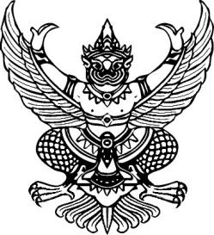

Announcement of Kam Pu Subdistrict Administrative Organization

Subject: Policy of not accepting neither gifts nor profits from performing duties (No Gift Policy)

Fiscal year 2025

Kam Pu Subdistrict Administrative Organization has emphasized on managing organization with good governance to build faith and confidence in society that Kam Pu Subdistrict Administrative Organization is the good governance organization, I as the Mr. Adisak Khunno , hereby declare and demonstrate my intention to perform duties and administer national affairs. I would perform my duties at the utmost of my ability with accountability, honesty and transparency in accordance with the guideline for promoting ethics and adhere to the principle of good governance. I hereby pledge that all Kam Pu Subdistrict Administrative Organization executives and Kam Pu Subdistrict Administrative Organization officials have intention of not accepting neither gifts nor profits from performing our duties, both before and after performing our duties which would cause corruption and misconduct at the present and in the future. I would also stand against all forms of corruption to promote the honesty value and create an integrity organization culture in strong and sustainable ways.

It is hereby announced and to adhered to all

This announcement is made on 22 January ,2025

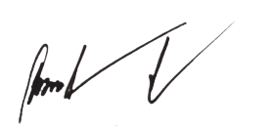

(Mr. Adisak Khunno)

President of Kam Pu Subdistrict Administrative Organization